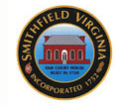
Isle of Wight County Museum
Volunteer Information

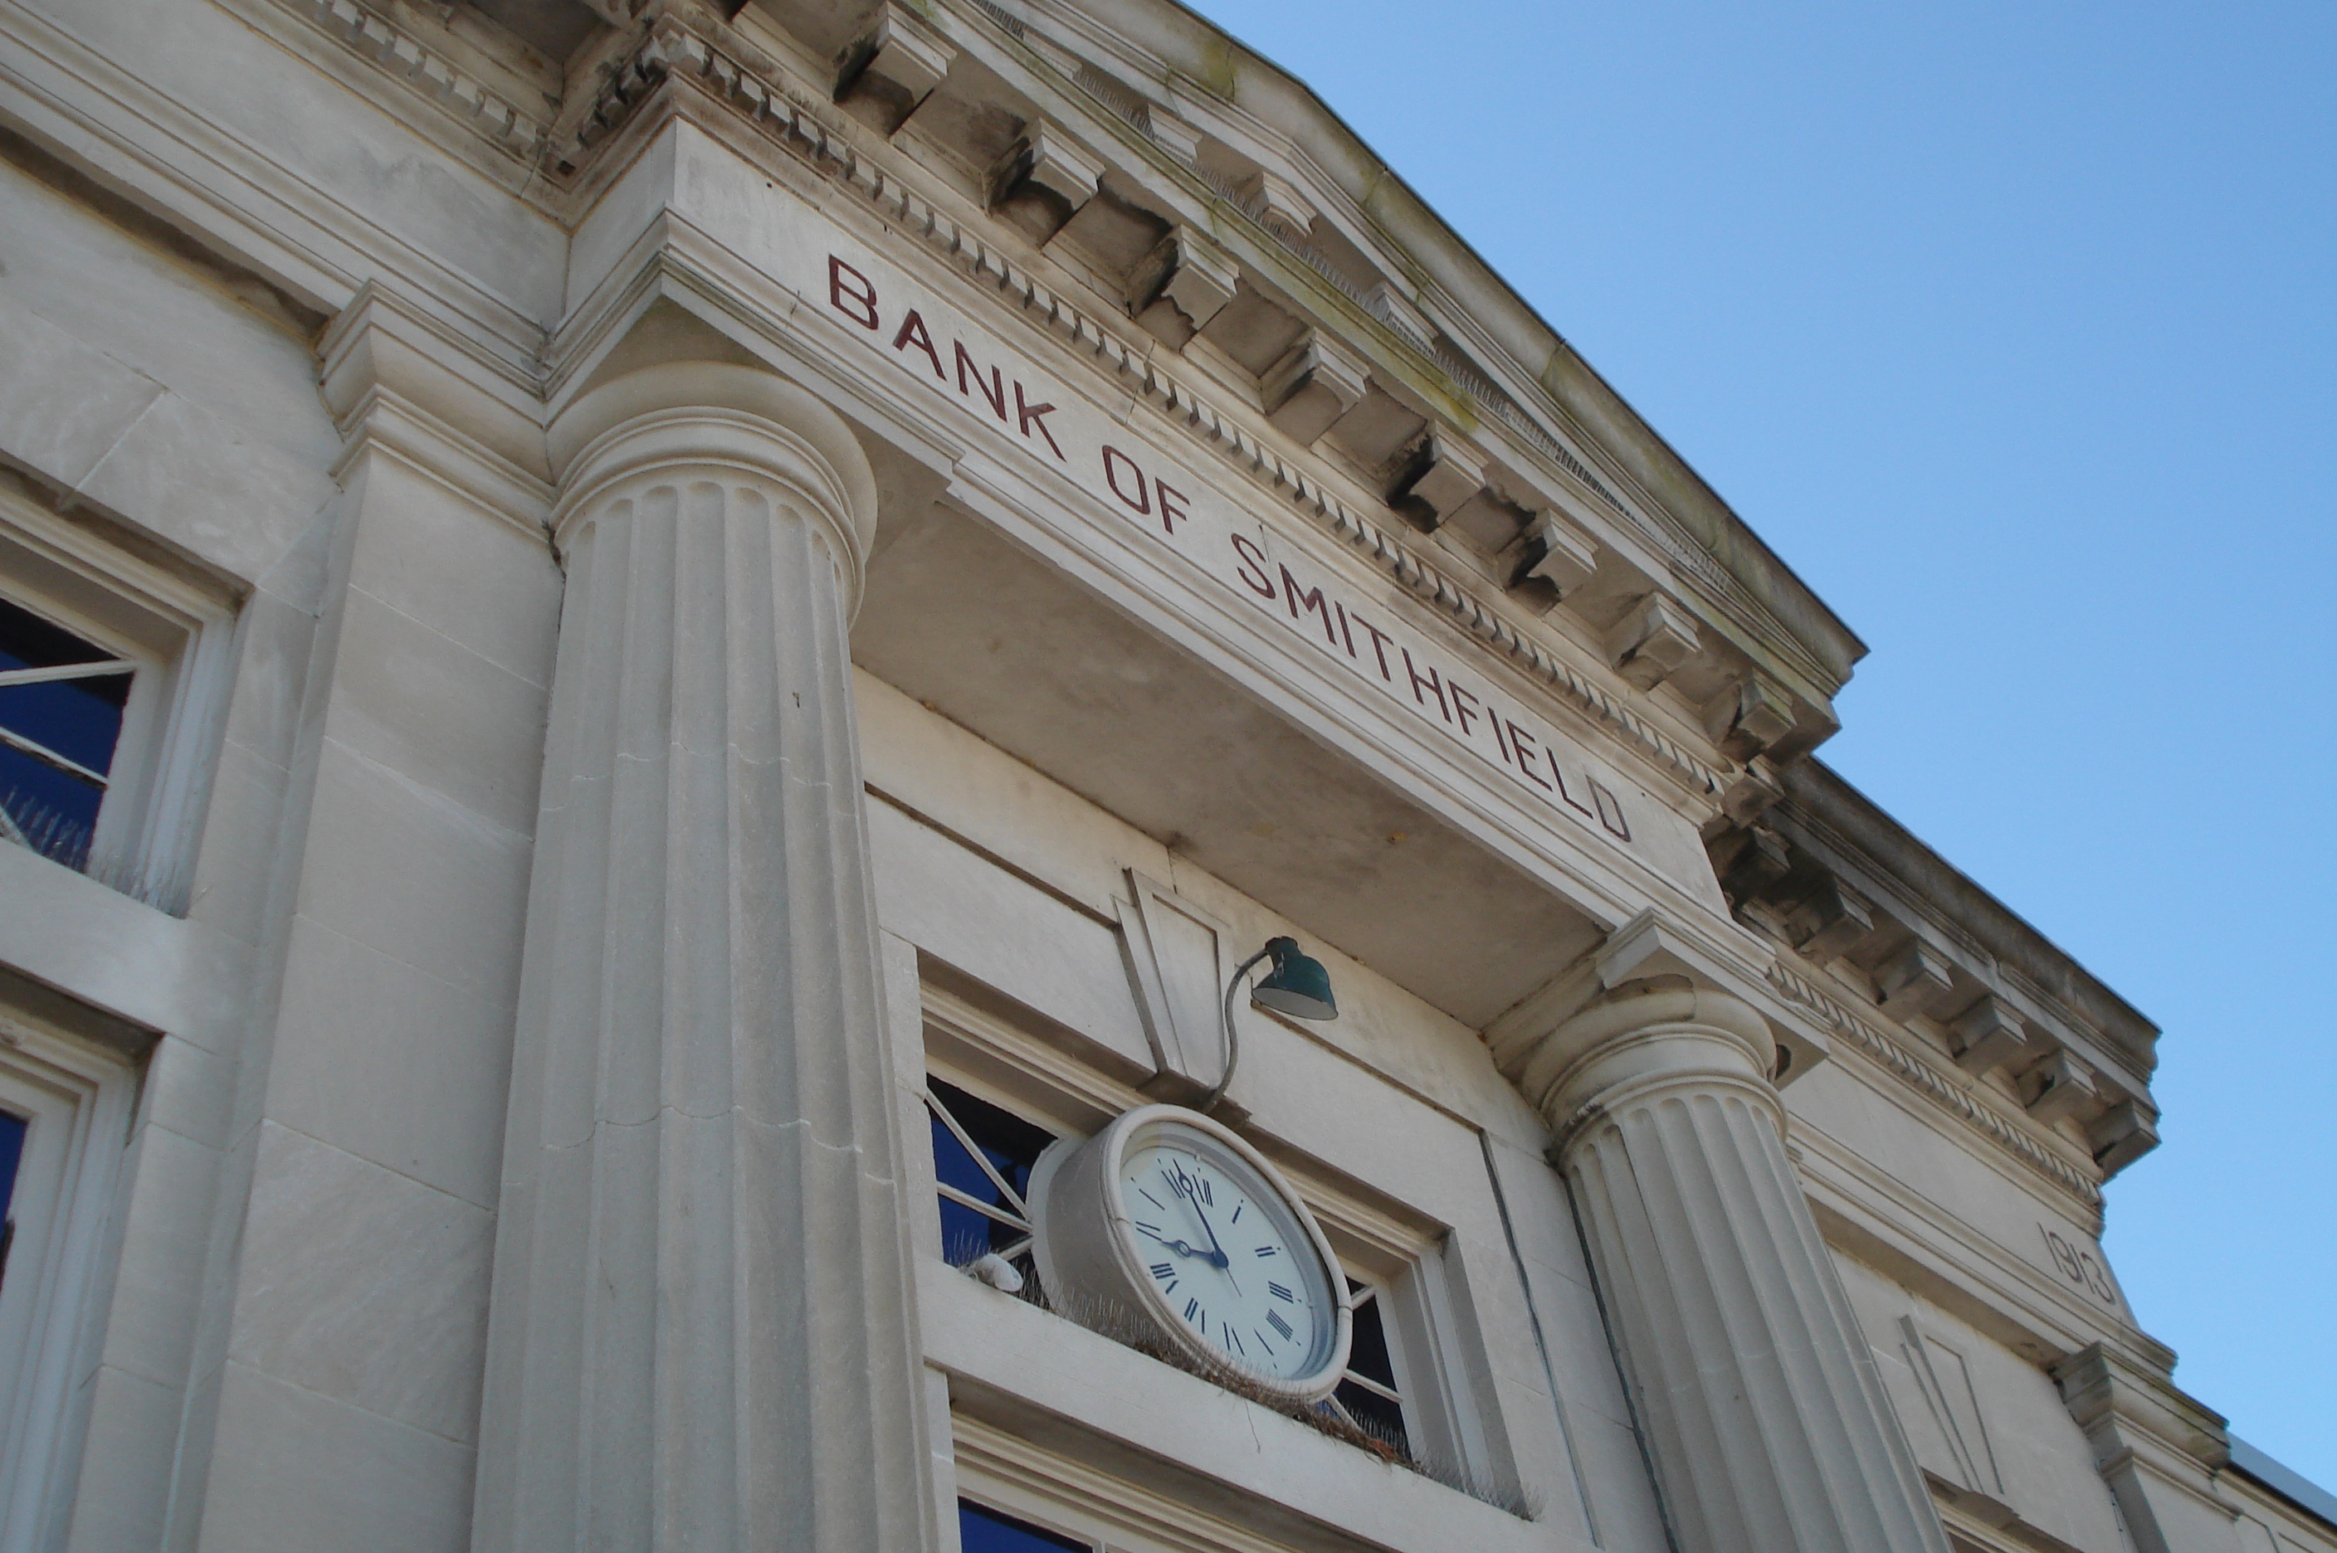

(Last edited August 2014)

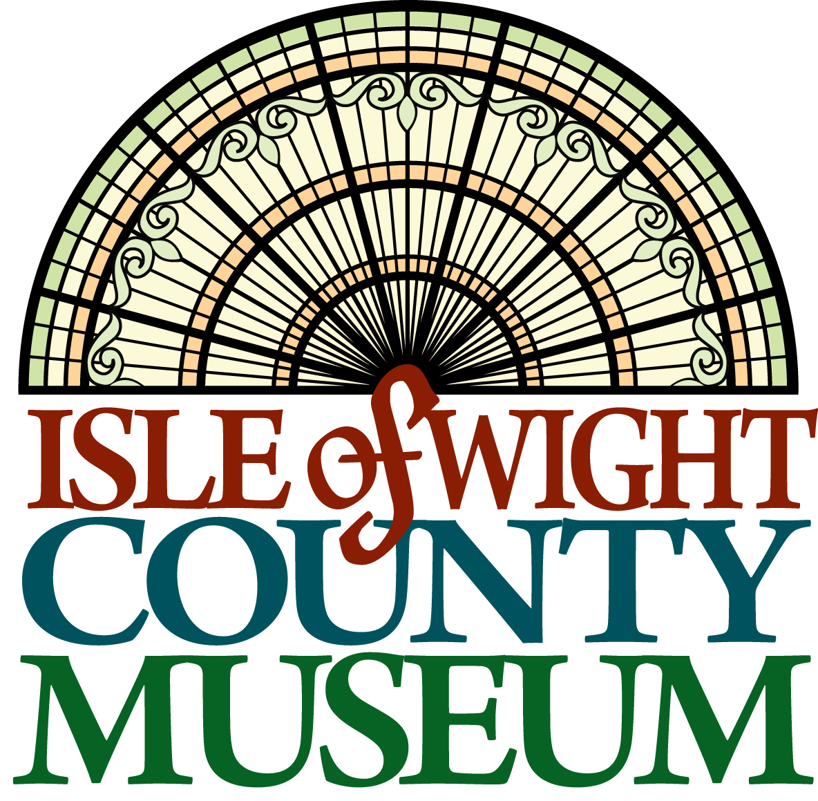

Dear Volunteer,

Welcome to the Isle of Wight County Museum!

Volunteers work hand-in-hand with division staff to develop and advance an understanding of the county’s heritage by conserving, interpreting and preserving its sociological, agricultural, archaeological, cultural, military and natural history.

Our volunteers truly make a difference, and we could not accomplish as much as we do without the time and energy of people like you.

We have opportunities available at all our sites for adults and youth ages 13 and up. We will work to meet your interests and skills with our needs.

Thank you for your interest in working with us.

Kind regards,

Museum Staff

Museum Code of Ethics and Professional Standards
For Volunteers
Museum Code of Ethics and Professional Standards
The Code of Ethics and Professional Standards are set forth for the protection of museum
associates and the Isle of Wight County Museum. They are designed to serve as objectives for
which all staff, both paid employees and volunteers, should strive and as a basis for disciplinary
action. All staff shall conduct themselves in accordance with the Museum Code of Ethics and
Professional Standards.

Museum Service Code of Ethics
- Service shall be undertaken for the betterment of the Isle of Wight County Museum and not for personal gain, other than the inherent reward derived from such participation.
- Paid staff members may not accept personal compensation for performance of their tasks. (Personal compensation includes gifts, fees, gratuities or other monetary distributions to the individual or to their immediate family or household.)
- Museum property, materials and supplies may be used only for official museum business.
- Staff with access to collections, research, staff activities and sensitive or proprietary information must respect the confidentiality of their positions, as well as the significance and integrity of the collections.
- Staff must be loyal to the mission of the museum and to the public which they serve.
- Paid staff is prohibited from engaging in any outside activity that might result in a conflict of interest -- actual, potential or perceived.

Museum Service Professional Standards**
The staff:
- understands and supports the purpose, structure and policies of the museum;
- offers the use of his or her special skills and experience;
- conducts himself or herself in accordance with the standards of conduct and ethics of the museum;
- completes museum orientation and other appropriate training;
- endeavors to be flexible in accepting assignments, performs assigned responsibilities willingly and courteously to the best of his or her ability and accepts the guidance of his or her supervisor;
- complies with the time and dress requirements of the museum;
- obeys all substance abuse, sexual harassment, security and safety rules of the museum;
- respects the confidentiality of sensitive or proprietary information;
- provides timely notification to the supervisor of absence or termination; serves as a goodwill ambassador and a communicator of the role of the museum in the community.
- will not espouse political or any controversial opinions in the presence of visitors that may be considered offensive
- must treat visitors, the general public and other staff members respectfully

Failure to abide by these ethics and standards may result
in termination of volunteer services.

Volunteer: Definition and Role
A volunteer is an individual registered with the division who freely chooses to work on a volunteer basis without financial compensation. The work is as varied as the museum itself and can include such functions as presenting educational programs, lab assistance, display renovations, research, clerical work, grounds maintenance and fundraising. A volunteer is reflective of their community and is vital to the division for their diverse points of view.

Volunteer Guidelines
All volunteers will be expected to:
- Make minimum commitments of time;
- Be reliable in attendance and punctuality;
- Record hours with their supervisor;
- Abide by museum policies;
- Maintain confidentiality of all proprietary or privileged information;
- Attend training required for their volunteer position;
- Attend continuing education programs to enhance their knowledge;
- Collaborate with staff and other volunteers;
- Accept supervision and evaluation of their volunteer work;
- Address concerns to their supervisor;
- Have good communications skills;
- Be a team player;
- Attend orientation and departmental training sessions;
- Coordinate work schedule to meet museum needs;
- Have a desire to help the museum fulfill its mission;
- Appreciate the need to maintain a professional business atmosphere in the work place and will respect the time pressures existing within the site for which they work; and
- Follow health and safety procedures for their work areas as outlined by their supervisor.

Staff/Volunteer Relationship
A successful volunteer program relies on the existence of a supportive working relationship between the volunteers and the staff. Staff working with or supervising volunteers will receive them as colleagues and provide appropriate training and encouragement. Staff is expected to make the best possible use of the skills, interests and prior experience of the volunteers under their direction and strive to provide for them challenging opportunities for their further acquisition of relevant skills and experience.

Volunteers will accept staff guidance and direction and exert themselves to learn and acquire new information and skills from the staff. Volunteers will make a responsible commitment to their work and carry out their duties as efficiently and independently as possible.

Volunteer Selection and Dismissal
The museum encourages diverse cultural and educational backgrounds in volunteers and offers various kinds of training and placement. Applicants for a volunteer position who are able to carry out the work required, will not be denied selection on the basis of race, national origin, religion, gender, sexual orientation, age disability or marital status. References may be required. Applicants under the age of 16 will be required to obtain written consent from a parent or guardian.
The museum may dismiss volunteers who are unable to carry out assigned duties or who do not act in the best interest of the division after consultation with the staff supervisor and department head.
Volunteer Placement in Programs
Prior to placement in any program, volunteers will be interviewed by museum staff.

Volunteer Benefits
- Learn about local history
- Meet visitors from your hometown and all over the world
- Free lectures and special events
- Exposure to the workings of an engaging museum system
- Work with others with similar interests
- Museum store discounts
- Satisfaction from giving back to the community

Volunteer Application and Emergency Contact Information

Last Name ______________________ First Name ____________________ MI________

Address______________________________________________________________________
City/State/ZIP ________________________________________________________________
Home Phone __________________________________________________________________
Cell _________________________________________________________________________
E-mail _______________________________________________________________________
Birthdate (Month and Day)______________________________________________________
Education ____________________________________________________________________

In which area(s) are you interested in volunteering?
____Administrative (data entry, office work)
____Education (programs, presentations, crafts)
____Buildings/Grounds (gardening, maintenance, exhibit construction, painting)
____Curatorial (cataloging, preservation, research)
____Visitor Services
____Events
____Other __________________________________

Please detail your availability:
__________________________________________________________________________________________________________________________________________________________________________________________________________________________________________

Previous/current volunteer experience ____________________________________________
______________________________________________________________________________
______________________________________________________________________________
______________________________________________________________________________

Background, hobbies, skills or special interests _____________________________________
____________________________________________________________________________________________________________________________________________________________
______________________________________________________________________________
______________________________________________________________________________

Do you have any certifications such as First Air or CPR? __yes __ no
If yes, please list dates of certification, agency and expiration date: ________________________

Please list any medical conditions or anything else the Town of Smithfield should know:
__________________________________________________________________________________________________________________________________________________________________________________________________________________________________________
Have you been convicted of a crime aside from minor traffic violations? __ yes __ no
If yes, please explain: ___________________________________________________________
______________________________________________________________________________
______________________________________________________________________________

References
Name Address Phone/E-mail Relationship
1. ____________________________________________________________________________
2. ____________________________________________________________________________
3. ____________________________________________________________________________

In case of emergency, please contact:
Name ________________________________________________________________________
Relationship ___________________________________________________________________
Address ______________________________________________________________________
Phone ________________________________________________________________________
E-mail ________________________________________________________________________

CERTIFICATION and AUTHORIZATION
I certify that the information provided in this application is true, correct and complete. I authorize verification of all statements contained in this application. I understand that my services may be contingent on a reference check, background check, interview, trial period and/or training.

______________________________________ ______________________________
Signature Date

______________________________________ ______________________________
Parent/Legal Guardian Signature Date

Volunteer Agreement

As a volunteer with the Town of Smithfield, I understand that I will be volunteering, either directly or indirectly, with visitors, residents, staff and the collection. I understand that compliance with all the requirements below is mandatory for volunteering and will minimize liability to the Town of Smithfield:

- I wish to volunteer my time, effort and services as a volunteer to assist the town.
- I have read and/or signed any applicable rules and statement of the town’s expectations of me as a volunteer, and I promise to follow them.
- As a volunteer, I will donate my time, effort and services with no compensation in return.
- I recognize and understand that my volunteer activities may expose me to the possibility of injury to my person and property and that I may suffer some kind of injury as a result of an accident or other unforeseen circumstances.
- I recognize that I am not covered by any workers’ compensation or similar insurance that would pay my medical bills because of any injury I received while performing services as a volunteer.
- Despite this risk of injury and lack of workers’ compensation or other medical insurance coverage from the town, I knowingly and voluntarily waive any and all claims, actions or causes of action against the town and agree to hold the Town of Smithfield, its trustees, agents, affiliates and employees harmless for any injury or damage that I may suffer as a result of my volunteer activities.
- In return for my agreement to these conditions, the town agrees to accept my services as a volunteer.
- I understand I may be photographed, recorded or videographed so that images – or likenesses - may be published in an outlet to promote or publicize the museum and/or town.
- I will inform a staff member of any previous injuries that may affect my ability to safely complete volunteer tasks – including lifting.
- I understand that I may not initiate or engage in any media/public event pertaining to the town or museum without approval from the museum director and/or the town manager. Requests for media engagements will be referred directly to the museum director and/or the town manager.
- I will not abuse, neglect, exploit, coerce, manipulate or remove any items, artifacts or supplies from the town or museum.
- I understand that I may receive personal information regarding a donation or loan that is not to be disclosed to an outside party in written or verbal form, nor in an electronic communication such as mail, website, text or social media.
- I understand that all visitors, residents and staff are to be treated with dignity, respect and consideration and are not to be discriminated against based on race, national origin, religion, gender, sexual orientation, age, disability or marital status.
- I understand that the terms listed above are not all-inclusive and may be updated as necessary.

_____________________________________ _ ______________________________
Signature Date

______________________________________ ________________________________
Parent/Legal Guardian Signature Date

